6
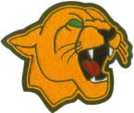

2016 Summer Reading List for
Incoming 6th Graders

8/13/2007

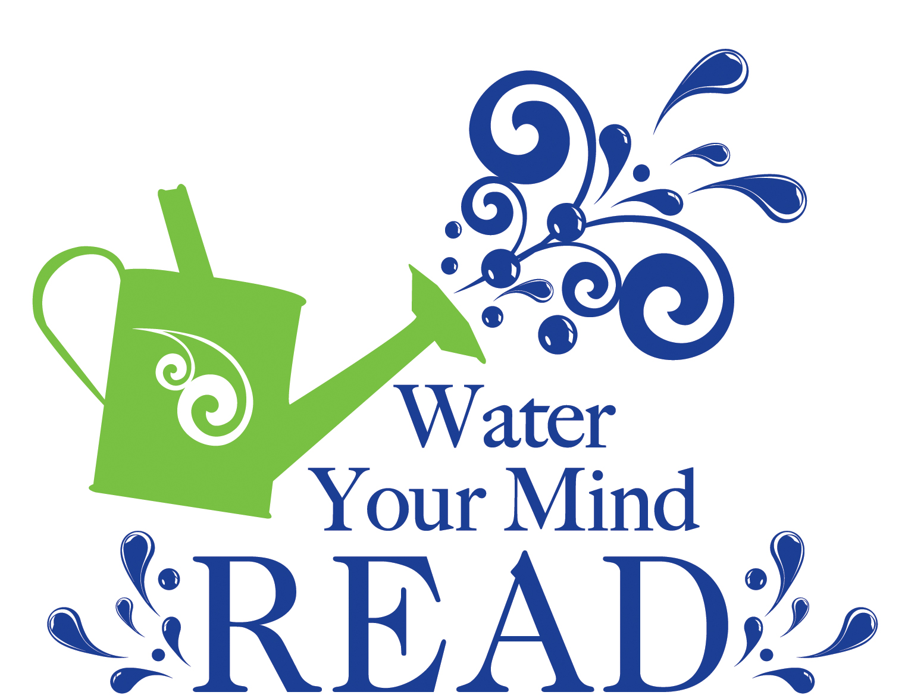
The 6th Grade English-Language Arts teachers are requesting that students read at least four of the thirteen books on the following list this summer. Research shows that students who do not engage in cognitive activities during the summer lose one to three months of learning. However, summer reading not only helps students retain the skills they need to enjoy academic success but also offers them enriching experiences through books. Students who read during the summer are more likely to:

- maintain fluency required for success
- maintain and increase their vocabulary
- learn of the resources provided by the public library
- have conversations with family and friends about books
- discover new interests and hobbies
- discover an enjoyment for reading

What you need to do:

- Choose three of the books on this list
- Complete the Summer Reading Log
- Have your parents sign your reading log.
- Turn your reading log in to your ELA teacher in the fall.

Every student who completes the summer reading requirements will participate in a special celebration during the 1st month of school.

6th Grade Summer Reading List

The 5th Wave by Rick Yancey

After the 1st wave, only darkness remains. After the 2nd, only the lucky escape. And after the 3rd, only the unlucky survive. After the 4th wave, only one rule applies: trust no one.
Now, it's the dawn of the 5th wave, and on a lonely stretch of highway, Cassie runs from them. The beings that only look human, who roam the countryside killing anyone they see. Who have scattered Earth's last survivors. To stay alone is to stay alive, Cassie believes, until she meets Evan Walker. Beguiling and mysterious, Evan Walker may be Cassie's only hope for rescuing her brother--or even saving herself. But Cassie must choose: between trust and despair, between defiance and surrender, between life and death; to give up or to get up.

Rules for Disappearing by Ashley Elston

She's been six different people in six different places: Madeline in Ohio, Isabelle in Missouri, Olivia in Kentucky . . . But now that she's been transplanted to rural Louisiana, she has decided that this fake identity will be her last. Witness Protection has taken nearly everything from her. But for now, they've given her a new name, Megan Rose Jones, and a horrible hair color. For the past eight months, Meg has begged her father to answer one question: What on earth did he do—or see—that landed them in this god-awful mess? Meg has just about had it with all of the Suits' rules—and her dad's silence. If he won't help, it's time she got some answers for herself. But Meg isn't counting on Ethan Landry, an adorable Louisiana farm boy who's too smart for his own good. He knows Meg is hiding something big. And it just might get both of them killed. As they embark on a perilous journey to free her family once and for all, Meg discovers that there's only one rule that really matters—survival.

The Water Castle by Megan Frazer Blakemore

Ephraim Appledore-Smith is an ordinary boy, and up until his father's stroke he lived an ordinary life. But all that changes when his family moves to the Water Castle-their ancestral home in the small town of Crystal Springs. Mallory Green's family has always been the caretakers of the Water Castle-and the guardians of its secrets. She has been raised to protect the legendary Fountain of Youth, hidden on the estate grounds. But ever since her mom left, she's stopped believing in magic. Will Wylie's family has been at war with the Applegates for generations, all because of the Water Castle's powerful secrets. But Will has rejected legend and magic, putting all his faith in science. When Ephraim learns of the Fountain, he's sure finding it can cure his dad. With Mallory and Will's help, the trio embarks on a mission that brings them deep into their families' shared history, through every secret room in the Water Castle, and on a quest that will blur the lines of magic and science, creativity and discovery, leaving readers left to wonder: Do you believe in the unbelievable?

Al Capone Does my Homework by Gennifer Cholden

"My name is Gaby, and I'm looking for a home where I can invite my best friend over and have a warm breakfast a couple of times a week. Having the newest cell phone or fancy clothes isn't important, but I'd like to have a cat that I can talk to when I'm home alone."
Gaby Ramirez Howard loves volunteering at the local animal shelter. She plays with the kittens, helps to obedience train the dogs, and writes adoption advertisements so that the strays who live there can find their forever homes: places where they'll be loved and cared for, no matter what.
Gaby has been feeling like a bit of a stray herself, lately. Her mother has recently been deported to Honduras and Gaby is stuck living with her inattentive dad. She's confident that her mom will come home soon so that they can adopt Gaby's favorite shelter cat together. When the cat's original owners turn up at the shelter, however, Gaby worries that her plans for the perfect family are about to fall apart.

Rump: The True Story of Rumpelstiltskin by Liesl Shurtliff

In a magic kingdom where your name is your destiny, 12-year-old Rump is the butt of everyone's joke. But when he finds an old spinning wheel, his luck seems to change. Rump discovers he has a gift for spinning straw into gold. His best friend, Red Riding Hood, warns him that magic is dangerous, and she’s right. With each thread he spins, he weaves himself deeper into a curse.
To break the spell, Rump must go on a perilous quest, fighting off pixies, trolls, poison apples, and a wickedly foolish queen. The odds are against him, but with courage and friendship—and a cheeky sense of humor—he just might triumph in the end.
A Texas Bluebonnet Master List Selection, Rump is perfect for fans of Gail Carson Levine's Ella Enchanted or Adam Gidwitz's A Tale Dark and Grimm.
"Lighthearted and inventive, Rump amusingly expands a classic tale." —Brandon Mull, #1 New York Times bestselling author of Fablehaven.

The Mighty Miss Malone by Christopher Paul Curtis

With love and determination befitting the "world's greatest family," twelve-year-old Deza Malone, her older brother Jimmie, and their parents endure tough times in Gary, Indiana, and later Flint, Michigan during the Great Depression.

Unstoppable by Tim Green

As a foster kid in a cruel home, Harrison knows his dream of one day playing for the NFL is a long shot. Then Harrison's luck seems to change.

Pinch Hit by Tim Green

"When movie star Trevor and regular Little League player Sam discover that they are identical twins who were separated at birth, they decide to trade places for a while so that Sam can live the Hollywood life and Trevor can play baseball"-- Provided by publisher.

One for the Murphys by Lynda Mullaly Hunt

"After heartbreaking betrayal, Carley is sent to live with a foster family and struggles with opening herself up to their love"-- Provided by publisher.

Chomp by Carl Hiaasen

When the difficult star of the reality television show "Expedition Survival" disappears while filming an episode in the Florida Everglades using animals from the wildlife refuge run by Wahoo Crane's family, Wahoo and classmate Tuna Gordon set out to find him while avoiding Tuna's gun-happy father.

Insignia by S.J. Kincaid

Twelve-year-old Fern feels invisible in her family, where grumpy eighteen-year-old Sarah is working at the family restaurant, fourteen-year-old Holden is struggling with school bullies and his emerging homosexuality, and adorable, three-year-old Charlie is always the center of attention, and when tragedy strikes, the fragile bond holding the family together is stretched almost to the breaking point.

Curveball: The Year I Lost My Grip by Jordan Sonnenblick
After an injury ends former star pitcher Peter Friedman's athletic dreams, he concentrates on photography which leads him to a girlfriend, new fame as a high school sports photographer, and a deeper relationship with the beloved grandfather who, when he realizes he's becoming senile, gives Pete all of his professional camera gear.

Name: _________________________________________________________

Summer Reading Log

Book Title/Author: ____________________________________________________

Brief Summary:

Book Title/Author: ____________________________________________________

Brief Summary:

Book Title/Author: ____________________________________________________

Brief Summary:

Book Title/Author: ____________________________________________________

Brief Summary:

Book Title/Author: ____________________________________________________

Brief Summary:

Date Completed: ____________________

Parent’s Signature: __________________________________________

